# Virtual Machine (VM) in Azure

## **Azure Virtual Machines**

Gives the flexibility of virtualization for a wide range of computing solutions, development and testing, running applications and extending on-premises data center. It is the freedom of software configured the way you need it. It is as if it was another rack in on-premises data center. it giving you the power to deploy an application in seconds instead of weeks.

Azure provides wide range support for creating VMs with [Linux](https://azure.microsoft.com/en-in/overview/choose-azure-opensource/), [Windows Server](https://azure.microsoft.com/en-in/campaigns/windows-server/), [SQL Server](https://azure.microsoft.com/en-in/services/virtual-machines/sql-server/), [Oracle](https://azure.microsoft.com/en-in/campaigns/oracle/), [IBM](https://azure.microsoft.com/en-in/campaigns/ibm/) and [SAP](https://azure.microsoft.com/en-in/services/virtual-machines/sap-hana/) etc.

Azure provides multiple ways of creating VM  
1. [Azure Portal](https://docs.microsoft.com/en-us/azure/virtual-machines/virtual-machines-windows-quick-create-portal?toc=%2fazure%2fvirtual-machines%2fwindows%2ftoc.json)  
2. [Azure PowerShell](https://docs.microsoft.com/en-us/azure/virtual-machines/virtual-machines-windows-quick-create-powershell?toc=%2fazure%2fvirtual-machines%2fwindows%2ftoc.json)  
3. [Azure CLI](https://docs.microsoft.com/en-us/azure/virtual-machines/windows/quick-create-cli)

This article focuses on creating VM using Azure Portal, to know more about Azure Powershell and creating VM using PowerShell, please refer [Azure Powershell](http://www.sharecareinspire.com/azure-powershell/)

Create VM Step by Step

**1.** Sign in the resource management portal [https://portal.azure.com](https://portal.azure.com/)

**2.** Select New -> Compute -> select desired VM image from the list -> select Resource Manager as deployment model -> Create

Azure Provides wide range of virtual machine images 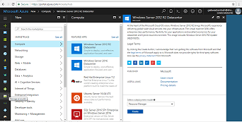

You can click on “See All” link to view all the available images.

**3.** VM Configuration details.  
You can select existing resource manager or can opt to create new. Select the datacenter location which would be nearest to the users. Name becomes the name of VM. User Name and Password becomes the credentials of local administrator of VM.

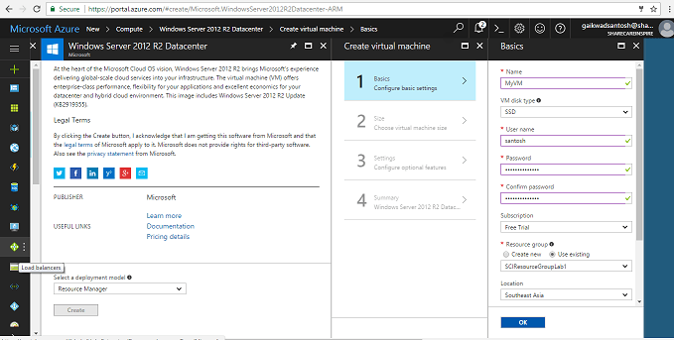

**4.** VM Size or pricing tier  
To see the complete list, click the View All link. Select the size that you want to use, and then click the Select button to return to the previous blade. If you want to know more about Virtual Network and Sub net, please refer another article [Understand Azure Virtual Network](http://www.sharecareinspire.com/understand-azure-virtual-network-cidr-notation-resource-group/).

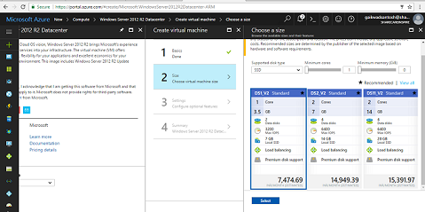

Following is the list of available VMs in different pricing tier

| Type | Sizes | Description |
| --- | --- | --- |
| [General purpose](https://docs.microsoft.com/en-us/azure/virtual-machines/virtual-machines-windows-sizes-general) | DSv2, Dv2, DS, D, Av2, A0-7 | Balanced CPU-to-memory ratio. Ideal for testing and development, small to medium databases, and low to medium traffic web servers. |
| [Compute optimized](https://docs.microsoft.com/en-us/azure/virtual-machines/virtual-machines-windows-sizes-compute) | Fs, F | High CPU-to-memory ratio. Good for medium traffic web servers, network appliances, batch processes, and application servers. |
| [Memory optimized](https://docs.microsoft.com/en-us/azure/virtual-machines/virtual-machines-windows-sizes-memory) | GS, G, DSv2, DS | High memory-to-core ratio. Great for relational database servers, medium to large caches, and in-memory analytics. |
| [Storage optimized](https://docs.microsoft.com/en-us/azure/virtual-machines/virtual-machines-windows-sizes-storage) | Ls | High disk throughput and IO. Ideal for Big Data, SQL, and NoSQL databases. |
| [GPU](https://docs.microsoft.com/en-us/azure/virtual-machines/virtual-machines-windows-sizes-gpu) | NV, NC | Specialized virtual machines targeted for heavy graphic rendering and video editing. Available with single or multiple GPUs. |
| [High performance compute](https://docs.microsoft.com/en-us/azure/virtual-machines/virtual-machines-windows-sizes-hpc) | H, A8-11 | Our fastest and most powerful CPU virtual machines with optional high-throughput network interfaces (RDMA). |

**5.** Summary  
Click OK on the summary blade, A VM is created from a VM image, which might correspond to one or more VHD files. e.g. OS & Data drives, these drives are .vhd files stored on storage account.

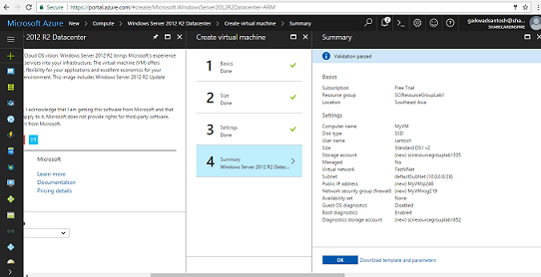

**6** Virtual machine in Portal  
You can see virtual machine in the list of all resources. Select the virtual machine and click on connect button to login. Use the credentials which were provided during creation of VM.

Azure Virtual Machines Agent and Extensions

The **Azure Virtual Machines Agent (VM Agent)** is a secured, light-weight process that installs, configures, and removes VM extensions on instances of Azure Virtual Machines. The VM Agent acts as the secure local control service for your Azure VM. There are two Azure VM Agents, one for Windows VMs and one for Linux VMs. By default, the VM Agent is automatically installed when you create a VM from the Image Gallery.

**Azure virtual machine extensions** are small applications that provide post-deployment configuration and automation tasks on Azure virtual machines. For example, if a virtual machine requires software installation, anti-virus protection, or Docker configuration, a VM extension can be used to complete these tasks. Azure VM extensions can be run by using the Azure CLI, PowerShell, Azure Resource Manager templates, and the Azure portal. Extensions can be bundled with a new virtual machine deployment or run against any existing system.

Different Azure VM extensions  
there are many different Azure VM extensions available, each with a specific use case.  
Some example use cases are:  
Configure virtual machine monitoring using custom script or PowerShell DSC.  
Configure an Azure virtual machine by using Chef.

How to check if VM agent is installed  
when logged in to a Windows Azure VM, task manager can be used to examine running processes. To check for the Azure VM Agent, open Task Manager > click the details tab, and look for a process name WindowsAzureGuestAgent.exe. The presence of this process indicates that the VM agent is installed.

**Custom Script Extension for Windows VM**The Custom Script Extension downloads and executes scripts on Azure virtual machines. This extension is useful for post deployment configuration, software installation, or any other configuration / management task. Scripts can be downloaded from Azure storage or GitHub, or provided to the Azure portal at extension run time. The Custom Script extension integrates with Azure Resource Manager templates, and can also be run using the Azure CLI, PowerShell, Azure portal, or the Azure Virtual Machine REST API.

The Azure custom script extensions allow the owner of the Azure VM to run script stored in Azure storage during or after VM provisioning. The script extension only executes once per VM, not every time the machine boots up – but if you stop the VM via Azure portal, and start the VM again, the VM will be re-provisioned, so the script will run again.  
If you need to run scripts repeatedly, you can add a timestamp parameter to your custom script extension.

**Deploy Extension using PowerShell**The Set-AzureRmVMCustomScriptExtension command can be used to add the Custom Script extension to an existing virtual machine.

Following is a example of Powershell script to create new website in IIS (MyScript.ps1), upload this file in Azure blob storage and refer same in PowerShell script.

Import-Module WebAdministration

$iisAppPoolName = "my-test-app"

$iisAppPoolDotNetVersion = "v4.0"

$iisAppName = "my-test-app.test"

$directoryPath = "D:\SomeFolder"

#navigate to the app pools root

cd IIS:\AppPools\

#check if the app pool exists

if (!(Test-Path $iisAppPoolName -pathType container))

{

    #create the app pool

    $appPool = New-Item $iisAppPoolName

    $appPool | Set-ItemProperty -Name "managedRuntimeVersion" -Value $iisAppPoolDotNetVersion

}

#navigate to the sites root

cd IIS:\Sites\

#check if the site exists

if (Test-Path $iisAppName -pathType container)

{

    return

}

#create the site

$iisApp = New-Item $iisAppName -bindings @{protocol="http";bindingInformation=":80:" + $iisAppName} -physicalPath $directoryPath

$iisApp | Set-ItemProperty -Name "applicationPool" -Value $iisAppPoolName

Set-AzureRmVMCustomScriptExtension -ResourceGroupName myResourceGroup `

    -VMName myVM `

    -Location myLocation `

    -FileUri myURL `

    -Run 'myScript.ps1' `

    -Name DemoScriptExtension

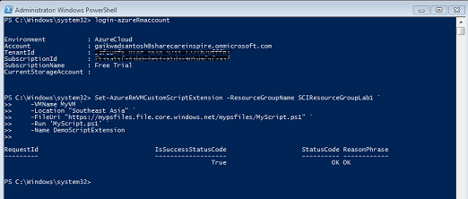PowerShell Script to install VM Extensions

Execute PowerShell script to update VM after setting up extension.